DESIGN AND PERFORMANCE ANALYSIS OF A PIPELINED PROCESSOR
WITH A MULTI-LEVEL CACHE MEMORY SYSTEM

CSA1221 – Computer Architecture

Report Based on the Required Design, Analytical Computation and Viva Deliverables
Analytical Processor Design Study

1. Introduction
This report presents an analytical design study of a single-core processor datapath and memory subsystem for an edge-computing workload. The design follows the assignment requirements for register transfer notation, multiple-bus organization, a 5-stage pipeline, hazard analysis, a 2-way superscalar extension, multi-level cache memory, virtual memory, AMAT, bandwidth and throughput comparison.
The proposed processor uses a 64-bit register file and datapath, a 5-stage IF-ID-EX-MEM-WB pipeline, forwarding and branch prediction for hazard mitigation, and a 2-way superscalar issue organization with out-of-order and speculative execution. The memory hierarchy contains L1, L2 and L3 caches backed by DRAM. MRAM is considered for a small non-volatile storage/cache-control level where persistence can be useful.
All numerical values in the report are design assumptions for analytical comparison. They are not measurements from physical silicon.

2. Deliverable Mapping
Deliverable | Implementation / Design Area
1 | Register-transfer datapath and processor design
2 | ALU operations and multiple-bus organization
3 | 5-stage pipeline design
4 | Data and control hazard analysis
5 | CPI calculation with and without mitigation
6 | 2-way superscalar, out-of-order and speculative execution
7 | L1/L2/L3 cache hierarchy and virtual memory
8 | AMAT and memory-system performance analysis
9 | Bandwidth, throughput comparison, reflection and SDG 9
10 | Complete end-to-end design demonstration and conclusion

Deliverable 1: Register-Transfer Datapath and Processor Design

Purpose
The datapath defines how instructions move operands between the program counter, register file, ALU, cache and memory. A multiple-bus arrangement is used so that two source operands can be read and supplied to the ALU without a single-bus bottleneck.

Pseudocode
START
Initialize PC and 32 × 64-bit register file
FETCH instruction from instruction cache using PC
DECODE opcode and identify source/destination registers
READ source operands through Bus A and Bus B
EXECUTE ALU operation or calculate memory address
IF load/store
ACCESS data cache
IF instruction writes a register
WRITE result through Bus C
UPDATE PC
STOP

Sample Input
Instruction Set | LOAD, STORE, ADD, SUB, BEQ
Register Width | 64-bit
Registers | 32
Bus Organization | Bus A, Bus B, Bus C

Sample Output
REGISTER-TRANSFER / MULTI-BUS DATAPATH
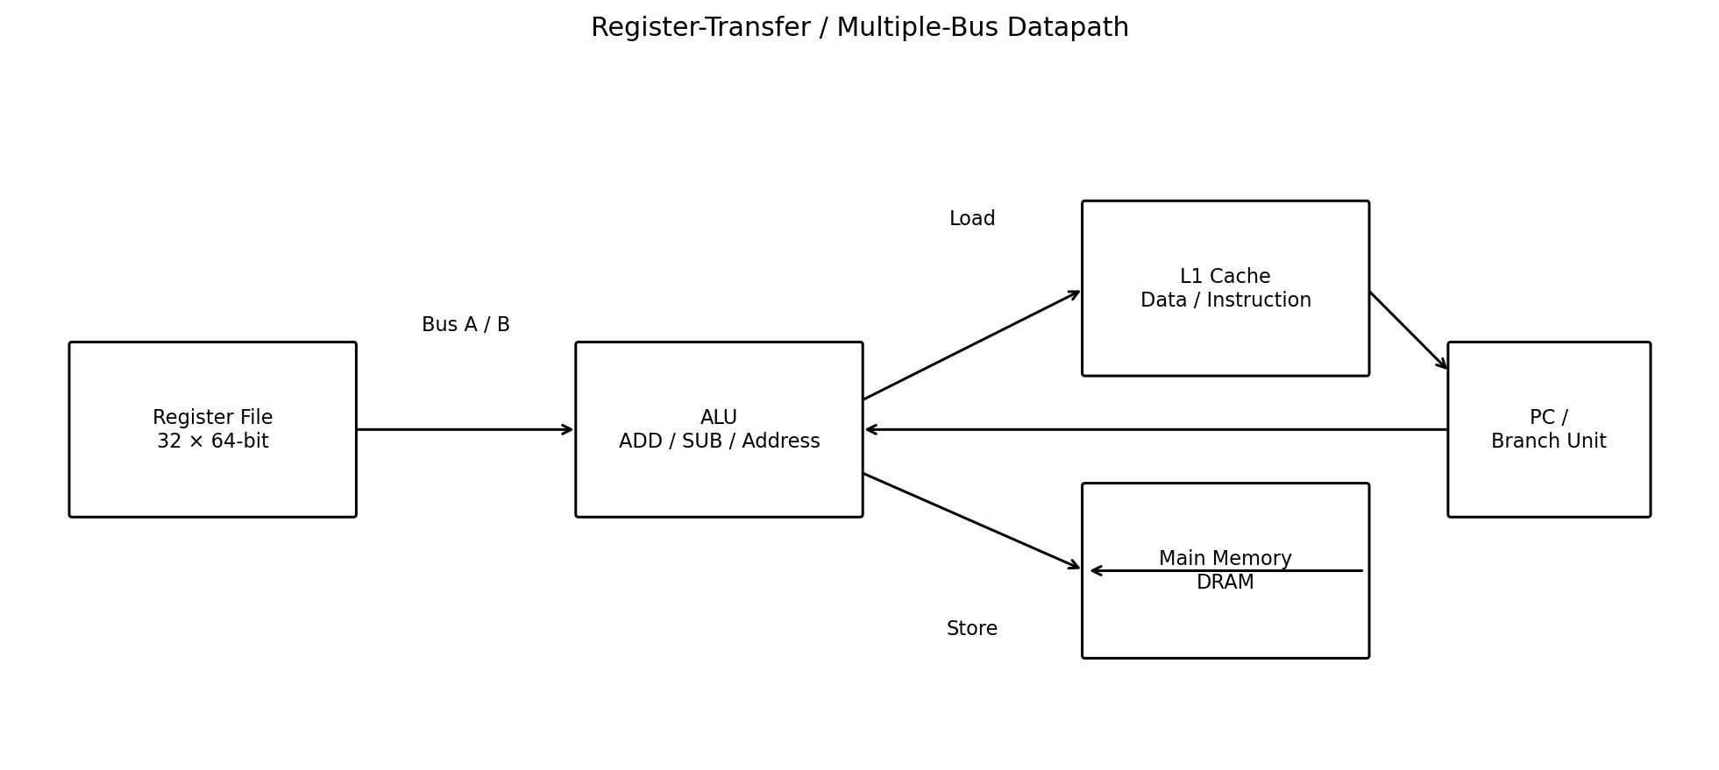

Result / Observation
The proposed datapath provides two operand-read paths and one result-write path. This supports ALU operations and memory-address calculation with fewer bus conflicts than a single-bus organization.

Deliverable 2: ALU Operations and Multiple-Bus Organization

Purpose
Register-transfer notation specifies the movement of data for the required instruction set. The ALU performs arithmetic, address-generation and branch comparison operations.

Pseudocode
LOAD R1, [R2 + imm] : MAR ← R2 + imm ; R1 ← M[MAR]
STORE R1, [R2 + imm]: MAR ← R2 + imm ; M[MAR] ← R1
ADD R3, R1, R4 : R3 ← R1 + R4
SUB R5, R3, R6 : R5 ← R3 - R6
BEQ R5, R0, L : IF R5 = R0 THEN PC ← L

Sample Input
Example | ADD R3, R1, R4
Bus A | R1 → ALU input A
Bus B | R4 → ALU input B
ALU | ADD
Bus C | ALU result → R3

Sample Output
R1 and R4 are transferred simultaneously on Bus A and Bus B; the ALU produces R1 + R4; Bus C writes the result into R3.

Result / Observation
The RTN and bus scheme clearly models inter-unit data movement and supports the required LOAD, STORE, ADD and branch operations.

Deliverable 3: 5-Stage Pipeline Design

Purpose
The scalar processor is divided into five stages: Instruction Fetch (IF), Instruction Decode/Register Read (ID), Execute (EX), Memory Access (MEM), and Write Back (WB).

Pseudocode
FOR each clock cycle
IF : fetch instruction and update fetch PC
ID : decode instruction and read registers
EX : perform ALU operation / address / branch comparison
MEM : access data cache for LOAD or STORE
WB : write result into destination register
END FOR

Sample Input
Pipeline | IF → ID → EX → MEM → WB
Clock | 2 GHz
Issue Width | 1 for scalar baseline

Sample Output
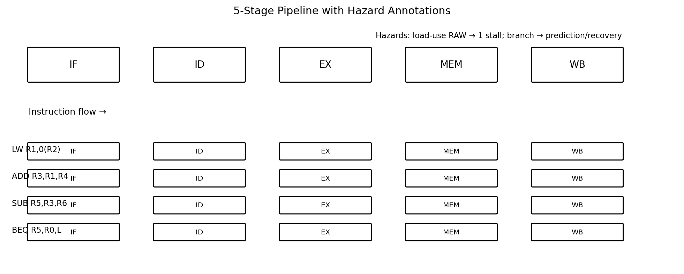

Result / Observation
The 5-stage pipeline allows multiple instructions to occupy different stages at the same time, increasing instruction throughput compared with a non-pipelined design.

Deliverable 4: Data and Instruction Hazard Analysis

Purpose
The selected instruction sequence contains RAW data dependencies and a conditional branch. These create data and control hazards that must be handled to maintain correct execution.

Pseudocode
Sequence:
I1: LW R1, 0(R2)
I2: ADD R3, R1, R4
I3: SUB R5, R3, R6
I4: BEQ R5, R0, TARGET
I5: ADD R7, R7, R8
FOR each dependency
IF producer result is unavailable
INSERT stall OR forward result
FOR branch
PREDICT direction
IF prediction is wrong
FLUSH younger instructions and restart at target

Sample Input
Data Hazard 1 | I1 → I2 (load-use RAW)
Data Hazard 2 | I2 → I3 (ALU RAW)
Control Hazard | I4 conditional branch

Sample Output
Without forwarding, dependent instructions wait for register write-back. With forwarding, the ALU dependency can be resolved directly; the load-use dependency still requires one stall in the assumed 5-stage pipeline. Branch prediction reduces control-hazard delay when the prediction is correct.

Result / Observation
At least two data hazards and one control hazard are explicitly identified and resolved using stalling, forwarding and prediction.

Deliverable 5: CPI Calculation With and Without Hazard Mitigation

Purpose
CPI is compared for the same 12-instruction workload. The baseline assumes no forwarding and a two-cycle dependency penalty for each of two RAW hazards, plus a two-cycle branch penalty. The mitigated design uses forwarding, one stall for the load-use dependency, and a correctly predicted branch.

Pseudocode
N ← 12
Ideal pipeline cycles ← N + 4
Unmitigated penalty ← 2 RAW × 2 + 1 branch × 2 = 6
Mitigated penalty ← 1 load-use stall + 0 branch penalty = 1
CPI ← (Ideal cycles + penalty) / N

Sample Input
Instructions | 12
Ideal pipeline cycles | 12 + 4 = 16
Unmitigated extra cycles | 6
Mitigated extra cycles | 1

Sample Output
Without mitigation: Total cycles = 16 + 6 = 22; CPI = 22 / 12 = 1.83.
With forwarding/stall/prediction: Total cycles = 16 + 1 = 17; CPI = 17 / 12 = 1.42.

Result / Observation
Hazard mitigation reduces the estimated CPI from approximately 1.83 to 1.42, demonstrating the performance value of forwarding and branch prediction.

Deliverable 6: 2-Way Superscalar, Out-of-Order and Speculative Execution

Purpose
The scalar pipeline is extended into a 2-way superscalar processor capable of dispatching up to two independent instructions per cycle. An issue queue, reservation stations, reorder buffer and separate execution units support out-of-order and speculative execution.

Pseudocode
FETCH up to 2 instructions
DECODE and RENAME registers
PLACE ready instructions in issue queue
WHILE execution units are available
SELECT ready instructions, possibly out of program order
EXECUTE on ALU0, ALU1 or Load/Store unit
WRITE results to waiting consumers
RETIRE instructions in program order using ROB
IF branch prediction is wrong
FLUSH younger ROB entries
RESTORE rename state
FETCH from correct target

Sample Input
Issue Width | 2 instructions/cycle
Execution Units | ALU0, ALU1, Load/Store
Scheduling | Out-of-order
Recovery | ROB flush + rename-state recovery

Sample Output
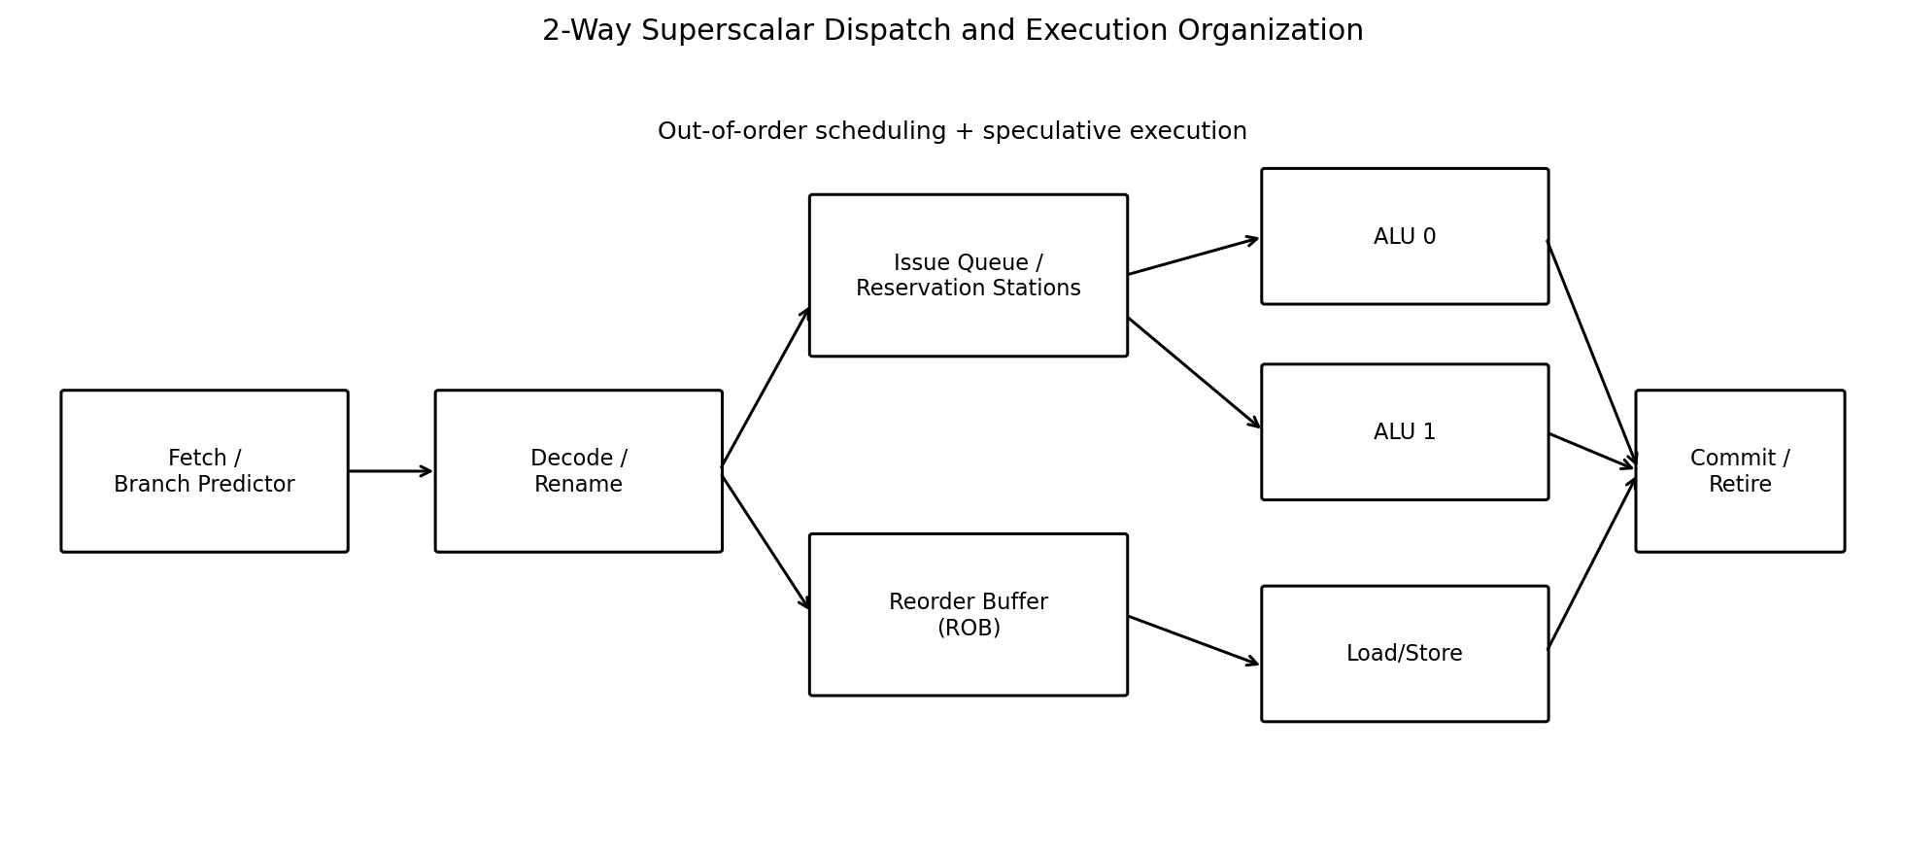

Result / Observation
The proposed superscalar design increases instruction-level parallelism while the reorder buffer preserves precise architectural state and enables recovery after branch misprediction.

Deliverable 7: L1/L2/L3 Cache Hierarchy and Virtual Memory

Purpose
The memory subsystem is designed to reduce average access latency while providing sufficient capacity for an edge-computing workload.

Pseudocode
L1: small, fast, private cache
IF hit → return data
ELSE access L2
L2: larger cache
IF hit → return data to L1
ELSE access L3
L3: shared last-level cache
IF hit → return data
ELSE access DRAM
Virtual memory:
Translate virtual page number using TLB
IF TLB miss → page-table walk
IF page not resident → page fault and fetch from storage

Sample Input
L1 Cache | 32 KB instruction + 32 KB data, 4-way, LRU
L2 Cache | 512 KB, 8-way, LRU
L3 Cache | 8 MB, 16-way, LRU
DRAM | Main memory, 80 ns assumed access
Page Size | 4 KB
TLB | 64-entry, 4-way
Non-volatile choice | MRAM for a small persistent cache/control level

Sample Output
The hierarchy is L1 → L2 → L3 → DRAM. LRU is used as the replacement policy because it is simple and effective for the assumed workload. Virtual memory uses 4 KB pages, with the TLB reducing repeated page-translation cost.

Result / Observation
The design satisfies the required cache-level, associativity, replacement-policy and paging decisions while balancing latency, capacity and implementation complexity.

Deliverable 8: AMAT and Memory-System Performance Analysis

Purpose
Average Memory Access Time is calculated for the proposed 3-level hierarchy and compared with a simpler 2-level design.

Pseudocode
AMAT = L1_hit_time
+ L1_miss_rate × (L2_hit_time
+ L2_miss_rate × (L3_hit_time
+ L3_miss_rate × DRAM_time))

Sample Input
L1 hit time / hit rate | 1 ns / 95%
L2 hit time / hit rate | 10 ns / 90%
L3 hit time / hit rate | 30 ns / 90%
DRAM penalty | 80 ns
Alternative A | 2-level: L1 + L2 + DRAM

Sample Output
Alternative A, 2-level AMAT = 1 + 0.05 × (10 + 80) = 5.50 ns.
Proposed 3-level AMAT = 1 + 0.05 × [10 + 0.10 × (30 + 80)] = 2.05 ns.
The additional L3 cache reduces AMAT by approximately 62.7% compared with the 2-level alternative.

Result / Observation
The 3-level cache hierarchy provides substantially lower average memory access time under the assumed hit rates.

Deliverable 9: Bandwidth, Throughput, Reflection and SDG 9 Relevance

Purpose
This deliverable compares scalar and 2-way superscalar performance and explains the design trade-offs and learning outcomes.

Pseudocode
Throughput (instructions/s) = Clock frequency / CPI
IPC = Issue width / CPI
Peak L1 interface bandwidth = Issue width × 8 bytes × Clock frequency
Compare:
Alternative A: scalar, 5-stage
Alternative B: 2-way superscalar, OOO/speculative

Sample Input
Clock | 2 GHz
Scalar mitigated CPI | 1.42
Superscalar assumed CPI | 0.75
Data path width | 64-bit = 8 bytes
Issue widths | 1-way vs 2-way

Sample Output
Scalar throughput ≈ 2 GHz / 1.42 = 1.41 billion instructions/s.
2-way superscalar throughput ≈ 2 GHz / 0.75 = 2.67 billion instructions/s.
Theoretical L1 data bandwidth is 16 GB/s for a 1-way 64-bit path and 32 GB/s for a 2-way path, assuming one 64-bit transfer per issued instruction.

Design Reflection
The major design trade-off is between complexity and performance. A 3-level cache adds area and power but significantly lowers AMAT. Forwarding and prediction require additional control logic but reduce pipeline stalls. Superscalar out-of-order execution improves instruction-level parallelism, while the reorder buffer and recovery logic increase implementation complexity.
A key implementation challenge is keeping the assumptions consistent across CPI, cache-hit rates and bandwidth calculations. The exercise demonstrates how datapath organization, pipeline hazards and memory latency interact rather than acting as isolated design problems.

SDG 9 Mapping
SDG 9 – Industry, Innovation and Infrastructure: The design supports the development of efficient and resilient computing infrastructure by improving processor throughput, reducing memory latency and evaluating architecture alternatives before hardware implementation.

Result / Observation
The 2-way superscalar design provides the higher analytical throughput, while the 3-level memory hierarchy provides the lower AMAT. The combined design is therefore selected as the preferred edge-computing architecture.

Deliverable 10: Complete End-to-End Design Demonstration

Purpose
The final demonstration connects all design decisions into one processor workflow, from instruction fetch through execution and memory access to retirement and performance evaluation.

Pseudocode
STEP 1 Initialize 64-bit register file and multi-bus datapath
STEP 2 Fetch and decode instructions
STEP 3 Execute using 5 pipeline stages
STEP 4 Detect RAW and control hazards
STEP 5 Apply forwarding, stall and branch prediction
STEP 6 Dispatch up to 2 instructions in superscalar mode
STEP 7 Schedule ready instructions out of order
STEP 8 Retire in order using the reorder buffer
STEP 9 Access L1 → L2 → L3 → DRAM when required
STEP 10 Calculate CPI, AMAT, bandwidth and throughput
STEP 11 Compare alternatives and select preferred design
END

Sample Input
Workload | 12-instruction dependency/branch sequence
Architecture | 2-way superscalar, 5-stage pipeline
Memory | L1 + L2 + L3 + DRAM
Evaluation | CPI, AMAT, bandwidth, throughput

Sample Output
STEP 1 Datapath and multi-bus organization defined.
STEP 2 Five pipeline stages established.
STEP 3 Two RAW hazards and one control hazard identified.
STEP 4 Forwarding, one load-use stall and branch prediction applied.
STEP 5 2-way out-of-order/speculative organization established.
STEP 6 L1/L2/L3 hierarchy and virtual memory integrated.
STEP 7 3-level AMAT calculated as 2.05 ns.
STEP 8 Scalar throughput ≈ 1.41 GIPS; superscalar estimate ≈ 2.67 GIPS.
END-TO-END PROCESSOR DESIGN ANALYSIS COMPLETED SUCCESSFULLY

Result / Observation
All required analytical components are integrated into a consistent processor design. The selected architecture combines a multiple-bus datapath, hazard-aware pipeline, 2-way superscalar execution and a 3-level cache hierarchy.

Overall Conclusion
The proposed processor design satisfies the assignment requirements by modelling register transfers and multiple-bus data movement, designing a 5-stage pipeline, identifying and resolving data and control hazards, calculating CPI, extending the design to a 2-way superscalar processor, and supporting it with L1, L2 and L3 caches plus virtual memory.
Under the stated assumptions, the mitigated scalar pipeline achieves an estimated CPI of 1.42, while the 2-way superscalar design is estimated at 2.67 billion instructions/s. The 3-level cache hierarchy achieves an AMAT of 2.05 ns compared with 5.50 ns for the 2-level alternative. These results justify the proposed combination of superscalar execution and multi-level caching for an edge-computing processor.
The numerical results are analytical estimates based on explicitly stated assumptions. Actual silicon performance would depend on workload behavior, technology node, cache implementation, branch accuracy, memory controller design, power limits and many other microarchitectural factors.

